Learning Goal
Creating visually appealing posters and album covers for our branding project.
Action
From weeks 2 to 5, we worked on a branding project for Woody Veneman and Truus de Groot's music duo project. The genre, neo-smartlappen, is a modern twist on the Dutch smartlappen style that Woody aims to introduce to younger audiences. Alongside creating stylescapes, I was responsible for designing album covers and posters.
Understanding Woody’s vision was challenging, so I invested a lot of time in research. I explored Woody's website, which provided some initial inspiration, but the most impactful source was an Instagram account Woody recommended: @ramusai, whose art deeply resonated with the kind of visual direction Woody wanted. I also immersed myself in Woody’s music, analysing the lyrics and sound to capture the emotions and themes his songs conveyed. This research was the backbone of my creative process.
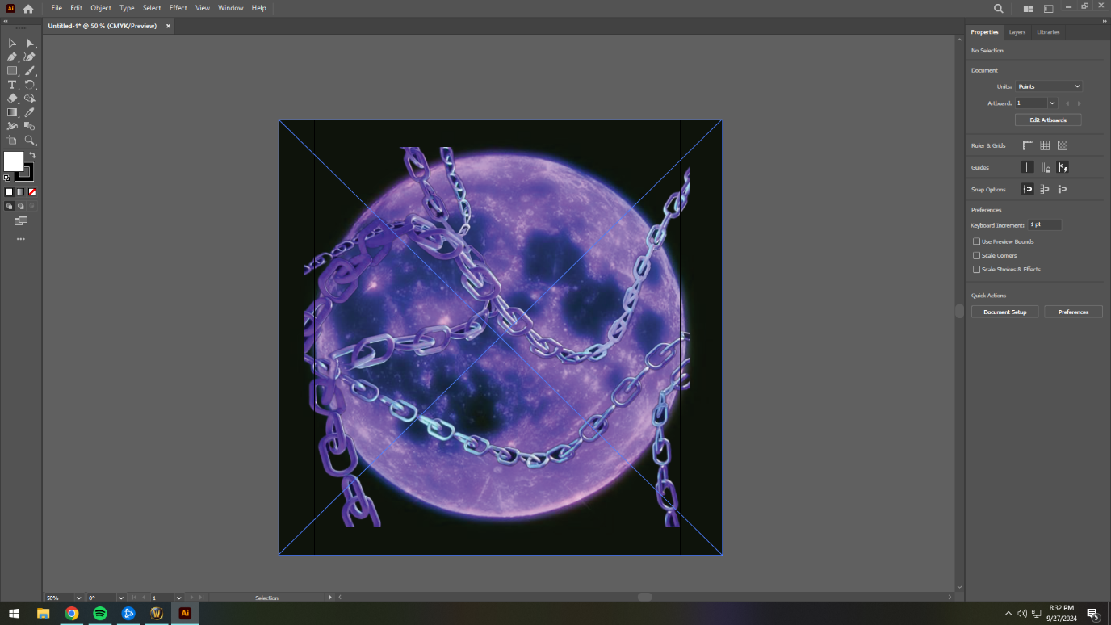
After multiple iterations, I refined the posters based on feedback that they were well-aligned but not eye-catching enough. Similarly, for the album covers, while the feedback was generally positive, I incorporated minor suggestions, such as testing how the logo would fit within the cover designs.

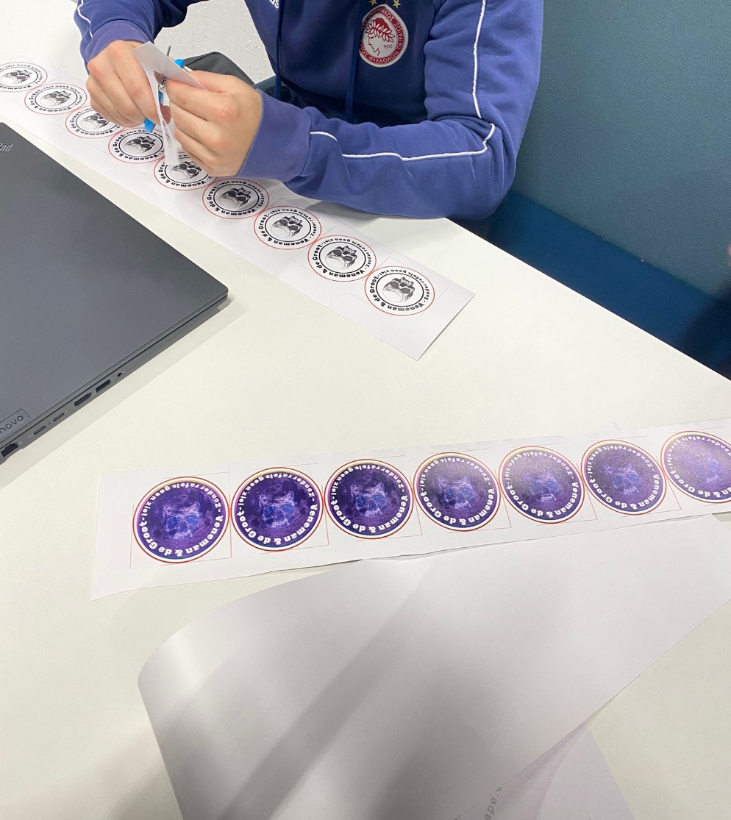

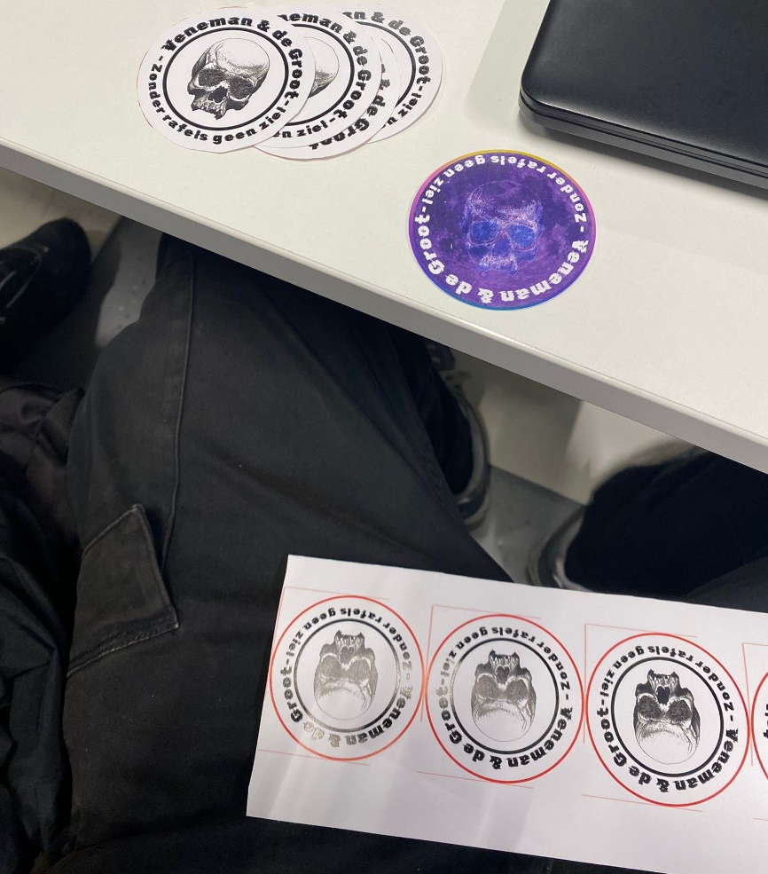
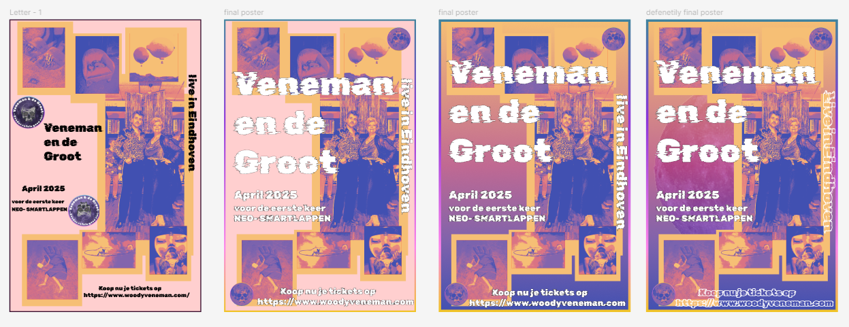
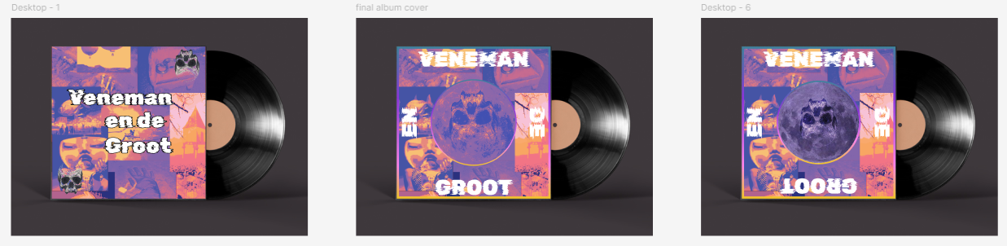
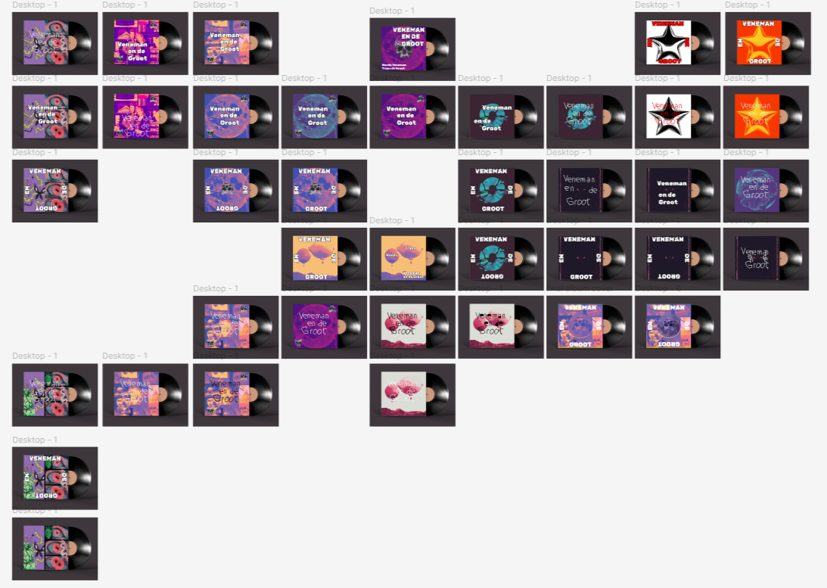
Result

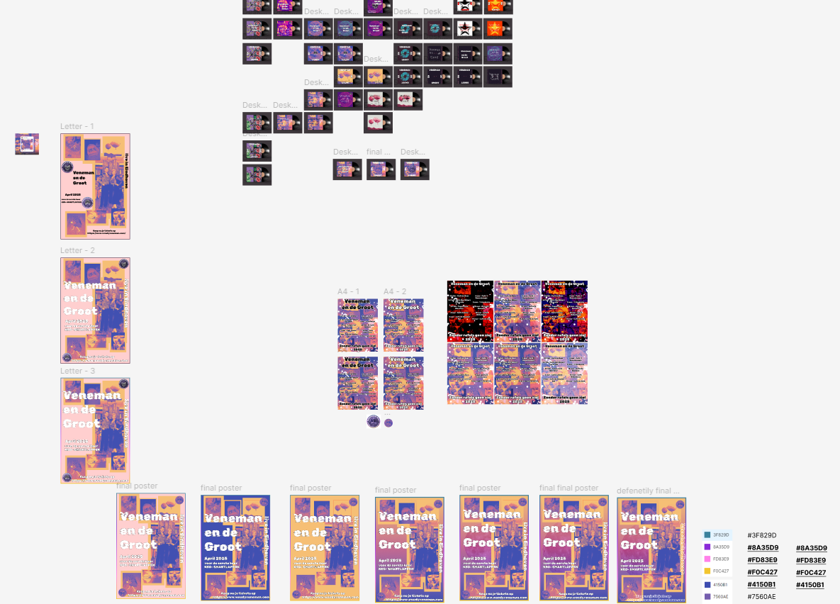
The research played a crucial role in shaping the final versions of both the posters and the album covers. By studying Woody’s music, his vision, and sources like the @ramusai Instagram account, I was able to refine my designs and align them with the mood of neo-smartlappen. The final posters achieved a more visually striking balance after several iterations, standing out more and catching the attention they initially lacked. For the album covers, the feedback was mostly positive from the start, but integrating feedback like logo placement helped enhance the final product. Overall, the deep dive into the client’s references allowed me to produce designs that resonated with Woody’s artistic direction.
Feedback
The feedback on the posters was initially focused on making them more visually appealing and striking. While the alignment and structure were solid, they needed to be bolder and less neat. After several iterations, I successfully improved their visual appeal. The album covers, on the other hand, received positive feedback, with only small suggestions like adding the logo for a more polished look.
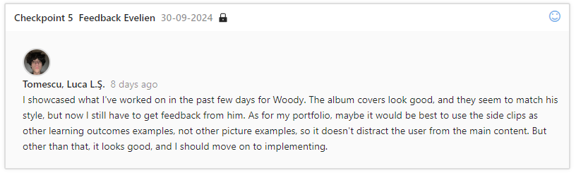
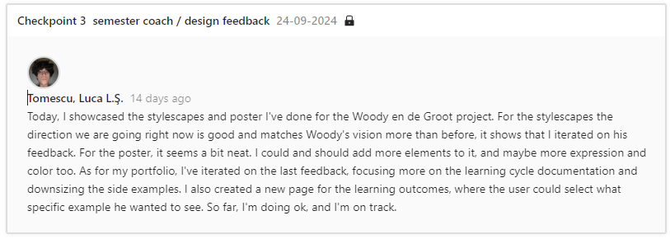
Reflection
This project taught me the importance of thorough research when it comes to understanding the client’s vision. Diving deep into Woody’s music, his references, and other inspirations allowed me to better align my designs with his brand. I realized that connecting with the client’s product is key to creating branding materials that not only meet expectations but also enhance the product’s identity.

Decide
In future projects, I will prioritize research early on to fully understand the client's vision and product. By immersing myself in their world, I can create designs that are more aligned with their goals. I also learned the value of iteration and feedback, as it allowed me to continuously improve the designs. Next time, I will ensure that I balance creativity with boldness, aiming for visuals that are both aligned and striking.

